USE Atif
GO
CREATE TABLE STUDENT (
Student_ID INT PRIMARY KEY,
Name VARCHAR(50),
Department VARCHAR(10),
CGPA DECIMAL(3, 2),
Admission_Year INT
);
CREATE TABLE COURSE (
Course_ID VARCHAR(10) PRIMARY KEY,
Course_Name VARCHAR(100),
Credit INT,
Instructor VARCHAR(50),
Department VARCHAR(10)
);

INSERT INTO STUDENT (Student_ID, Name, Department, CGPA, Admission_Year) VALUES
(101, 'Rafiq', 'CSE', 3.75, 2021),
(102, 'Nabila', 'EEE', 3.60, 2020),
(103, 'Hasan', 'CSE', 3.90, 2019),
(104, 'Tania', 'BBA', 3.40, 2022),
(105, 'Reza', 'EEE', 3.10, 2021);

INSERT INTO COURSE (Course_ID, Course_Name, Credit, Instructor, Department) VALUES
('C101', 'Database Systems', 3, 'Dr. Karim', 'CSE'),
('C102', 'Circuit Theory', 3, 'Dr. Rahman', 'EEE'),
('C103', 'Marketing Basics', 2, 'Dr. Jahan', 'BBA'),
('C104', 'Computer Networks', 3, 'Dr. Alam', 'CSE'),
('C105', 'Control Systems', 3, 'Dr. Rahman', 'EEE');
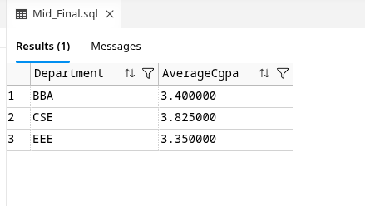
-- Question-1
SELECT
st.Department ,
AVG(st.CGPA) AS AverageCgpa
FROM STUDENT st
GROUP BY st.Department

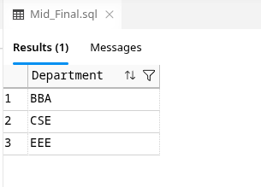

-- Question-2
SELECT DISTINCT(st.Department)
FROM STUDENT st;

-- Question-4
SELECT cr.Instructor, cr.Department, SUM(Credit) AS TotalCredit
FROM COURSE cr
GROUP BY cr.Department, cr.Instructor
ORDER BY SUM(Credit) DESC
OFFSET 0 ROWS FETCH FIRST 1 ROWS ONLY
